ARPIE  midi arpeggiator  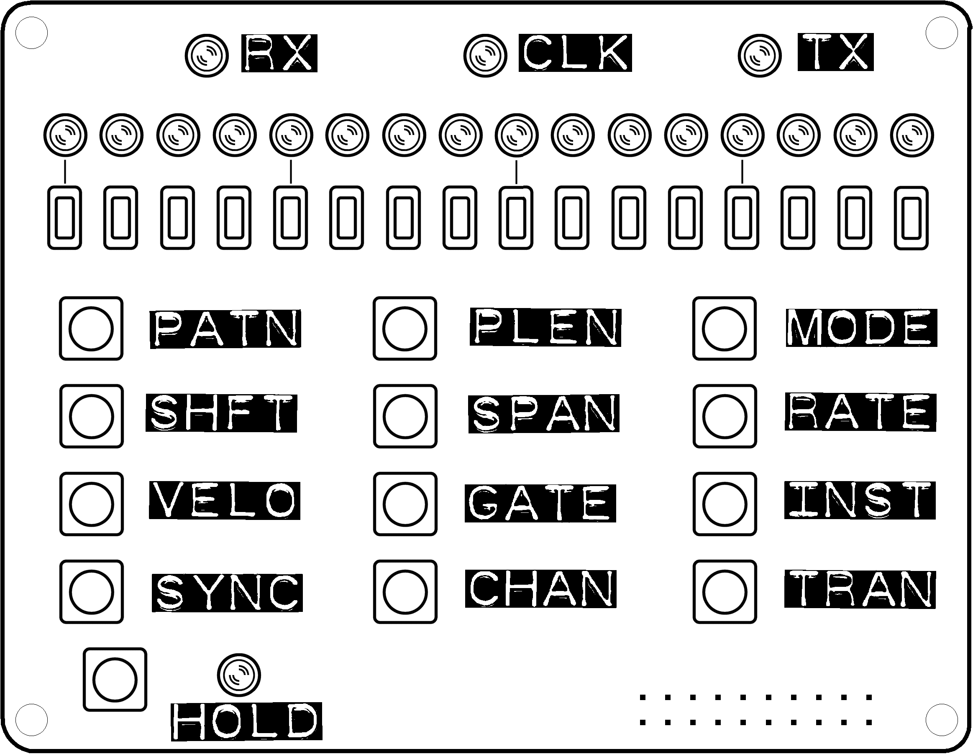  Thankyou for your purchase of an ARPIE kit!  The information on this sheet is the bare minimum needed to build the kit. However, you will find additional information and tips at six4pix.com/arpie  ARPIE Component Designators  R1, R2, R3, R4, R18 - 220 Ohm (red-red-brown code) resistor  R5, R6, R7, R8 -1.5 kOhm (brown-green-red code) resistor  R9, R10, R13 - 10 kOhm (brown-black-orange code ) resistor  R11, R12, R14, R15, R16, R17, R19, R20 - 1 kOhm (brown-black-red code) resistor  D1, D2 - 1N4148 Small Signal Diode (small orange/black glass package). Align cathode stripe with corresponding marking on PCB.  D3, D4, D5, D6 - 1N4001 Rectifier Diode (black plastic package, silver lettering). Align cathode stripe with corresponding marking on PCB.  C1, C2, C3, C4, (C9) - 100nF Ceramic Capacitor (104 code). C9 is optional and allows auto-reset during firmware upload.  C5, C6 - 33pF Ceramic Capacitor (33 code)  C7, C8 - 4.7uF Electrolytic Capacitor (polarised, check negative terminal marked on package and PCB)  X1 - 16MHz Crystal  TR1 - 2N3904 General Purpose NPN Transistor (polarity matters, check outline on PCB)  Solder the IC sockets before fitting IC's. Check orientation of pin 1 notch/dimple with markings on PCB)  IC1 -ATMega328P Microcontroller with firmware  IC2 - PIC12F1822 Microcontroller with firmware  IC3, IC4 - 6N138/6N139 High Speed Opto-Coupler  Check voltage regulator (IC5) orientation against markings on the PCB  IC5 - 7805-TO220 +5V Voltage Regulator  LEDs – ARPIE uses a row of 16 blue LEDs on the control surface PCB. The control surface has 4 other indicator LEDs (suggested red) and the main board has 3 diagnostic LEDs (suggested green). Feel free to use the supplied green and red LEDs as you wish. Remember the anode (positive) terminal of an LED has the longer lead.  6-Pin Headers - solder the male header in the “Serial Prog” position and the 6-pin female header in the position next to TR1.  Switches, Battery holder + M2.5 nuts/bolts, Sockets, Pin Headers, Standoff Pillars + M3 bolts – it should be reasonably obvious where all those bits go but if in any doubt please refer to the build instructions at the URL given above.  I hope you enjoy your ARPIE. If you have any questions or comments, please contact me at goarpie@gmail.com or via the site where you ordered your kit. ARPIE is an open source, open hardware project. All input is welcome, from wish-list ideas to actual code. If you do something amazing with your ARPIE I'd love to see it  Cheers / Jason Hotchk155 | ARPIE  midi arpeggiator  Thankyou for your purchase of an ARPIE kit!  The information on this sheet is the bare minimum needed to build the kit. However, you will find additional information and tips at six4pix.com/arpie  ARPIE Component Designators  R1, R2, R3, R4, R18 - 220 Ohm (red-red-brown code) resistor  R5, R6, R7, R8 -1.5 kOhm (brown-green-red code) resistor  R9, R10, R13 - 10 kOhm (brown-black-orange code ) resistor  R11, R12, R14, R15, R16, R17, R19, R20 - 1 kOhm (brown-black-red code) resistor  D1, D2 - 1N4148 Small Signal Diode (small orange/black glass package). Align cathode stripe with corresponding marking on PCB.  D3, D4, D5, D6 - 1N4001 Rectifier Diode (black plastic package, silver lettering). Align cathode stripe with corresponding marking on PCB.  C1, C2, C3, C4, (C9) - 100nF Ceramic Capacitor (104 code). C9 is optional and allows auto-reset during firmware upload.  C5, C6 - 33pF Ceramic Capacitor (33 code)  C7, C8 - 4.7uF Electrolytic Capacitor (polarised, check negative terminal marked on package and PCB)  X1 - 16MHz Crystal  TR1 - 2N3904 General Purpose NPN Transistor (polarity matters, check outline on PCB)  Solder the IC sockets before fitting IC's. Check orientation of pin 1 notch/dimple with markings on PCB)  IC1 -ATMega328P Microcontroller with firmware  IC2 - PIC12F1822 Microcontroller with firmware  IC3, IC4 - 6N138/6N139 High Speed Opto-Coupler  Check voltage regulator (IC5) orientation against markings on the PCB  IC5 - 7805-TO220 +5V Voltage Regulator  LEDs – ARPIE uses a row of 16 blue LEDs on the control surface PCB. The control surface has 4 other indicator LEDs (suggested red) and the main board has 3 diagnostic LEDs (suggested green). Feel free to use the supplied green and red LEDs as you wish. Remember the anode (positive) terminal of an LED has the longer lead.  6-Pin Headers - solder the male header in the “Serial Prog” position and the 6-pin female header in the position next to TR1.  Switches, Battery holder + M2.5 nuts/bolts, Sockets, Pin Headers, Standoff Pillars + M3 bolts – it should be reasonably obvious where all those bits go but if in any doubt please refer to the build instructions at the URL given above.  I hope you enjoy your ARPIE. If you have any questions or comments, please contact me at goarpie@gmail.com or via the site where you ordered your kit. ARPIE is an open source, open hardware project. All input is welcome, from wish-list ideas to actual code. If you do something amazing with your ARPIE I'd love to see it  Cheers / Jason Hotchk155

